

Dear Scholar,

We are delighted to announce that Legacy, by Philip Ziegler, which the Trust commissioned, is complete and ready for sale. It is a remarkable book, tracing the evolution of the Trust and its Scholarship programme from Rhodes’ vision in 1902 to the new world of the twenty-first century. Philip Ziegler writes with an easy, accessible style without sacrificing any of the rigour and precision that an authorised history of the Trust requires. Rhodes Scholars will be fascinated by this account which puts their experience in context. It is compelling reading also for anyone interested in the evolution of the British outlook as the country retreated from Empire.

Philip Ziegler is well-known historian writing authoritative books for the general public. Among his best known books are biographies of Mountbatten, King Edward VIII, Lord Melbourne, and Osbert Sitwell. He is currently engaged on the official biography of Edward Heath.

Copies are available for purchase from the Trust, at a reduced rate of:
- £15, which includes postage to UK addresses
- £20, which includes postage to EU addresses or surface mail to the rest of the world, or
- £25, which includes airmail postage to the rest of the world. (The UK RRP is £25.) Scholars may purchase as many copies as they wish. Payment may be made by UK cheque, made out to The Rhodes Trust, or by credit card. If using a credit card, please complete the attached form so that we may debit your card

With very best wishes,
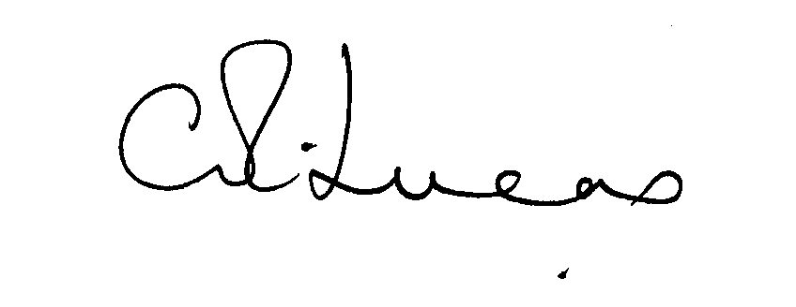

Sir Colin Lucas
Warden

Please fax this form to: +44 1865 270914

Or:

Post it to: Catherine King
Rhodes House
Oxford OX1 3RG
UK

For your own card security, please don’t e-mail these details.

Please debit my credit card for UK £…………………….

My card is a: Visa / Mastercard / American Express (NB: We cannot take Diners Club.)

My card number is: ……………………………………………………………………………………

My name as it appears on my card is: ………………………………………………………………...

My card is valid from ……………………...……………… to …….…………….….………………

The three-digit security code on the reverse of my card is: ………………………………………….

I would like to purchase …………… copy/ies of Legacy and these should be mailed by

Air / Surface mail to:

…………………………………………………………………………

…………………………………………………………………………

…………………………………………………………………………

…………………………………………………………………………

…………………………………………………………………………

Signed: ………………………………………………. Dated: ………………………………………

Print name: ………………………………………………..

